

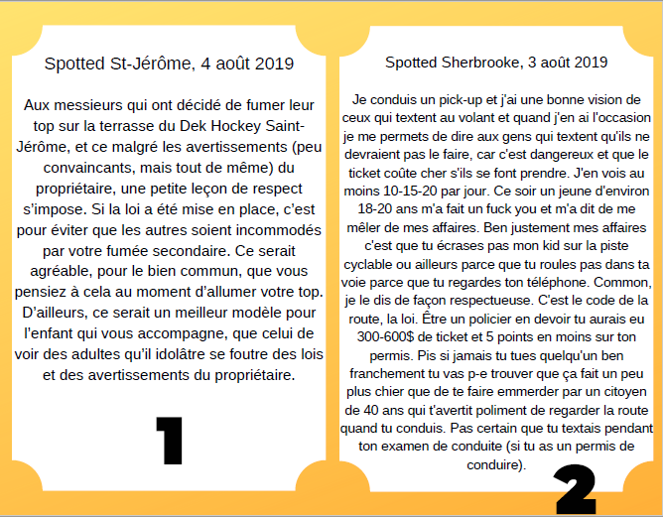

|  |  |
| --- | --- |
| **Thèse défendue** | **Thèse défendue** |
|  |  |

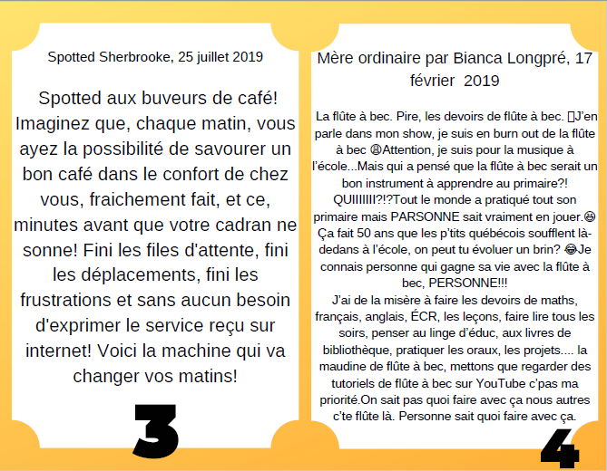

|  |  |
| --- | --- |
| **Thèse défendue** | **Thèse défendue** |
|  |  |

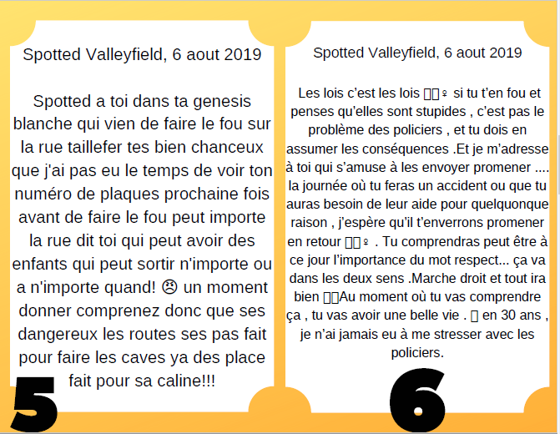

|  |  |
| --- | --- |
| **Thèse défendue** | **Thèse défendue** |
|  |  |

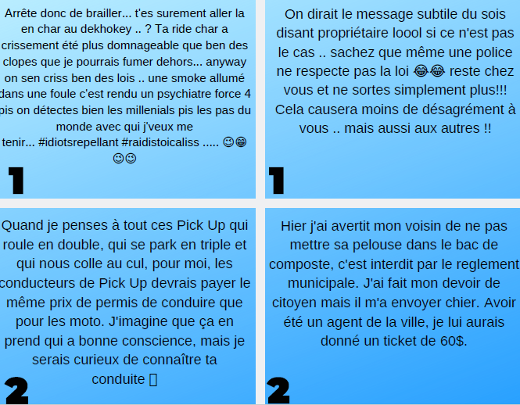

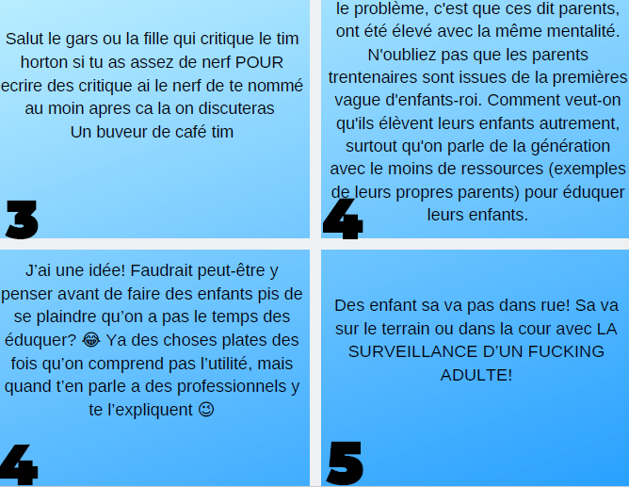

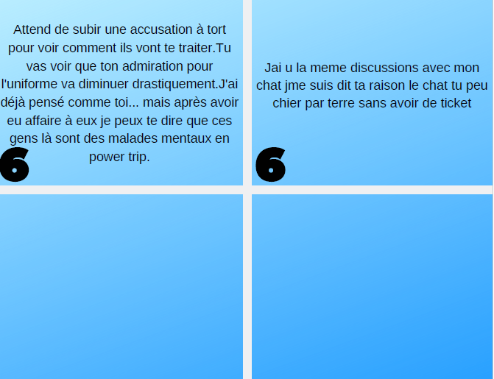

_____________________________________________________________________________________________________________________________________________________________________________________________________________________________________________________________________________________________________________________________________________

_______________________________________________________________________________________________________________________________________________________________________________________________________________________________________________________________________________________________________________________________________________________________________________________________________________________________________

Contre-argument modifié # _____________ Contre-argument modifié # _____________

